|  |  |
| --- | --- |
|  | |
| ALL-607: COA – Forecast [Forecast Screen – TEU, Weight, Unit Columns]  Functional Specification | |
| Department: CMA CGM Commercial Allocation  Project: *DATAWAYS*  JIRA ID: ALL-607  Author(s): *Infosys* | |
| **Doc Reference:**  **Date:**  **Version:**  **Status:** | ALL-607: COA – Forecast [Forecast Screen – TEU, Weight, Unit Columns]  29.07.24  1.0  Draft To Be Reviewed |
| Classification: **Internal** | |

REVISIONS

|  |  |  |  |
| --- | --- | --- | --- |
| **Version** | **Date** | **Author** | **Subject** |
| 1.0 | 29-Jul-24 | Dinesh Maurya | Document creation |
| 1.1 | 22-Oct-24 | Dinesh Maurya | Document creation |

**REVIEWS**

|  |  |  |  |  |  |
| --- | --- | --- | --- | --- | --- |
| **Name** | **Title** | **Version** | **Date** | **Company** | **Signature** |
| Prabhu SESHADRI | IT Domain Lead | 1.0 |  | CMA CGM | Prabhu SESHADRI |
| HIENG Laurent | Product Owner | 1.0 |  | CMA CGM | HIENG Laurent |

APPROVALS

|  |  |  |  |  |  |
| --- | --- | --- | --- | --- | --- |
| **Name** | **Title** | **Version** | **Date** | **Company** | **Signature** |
| HOELLARD Damien | Lead Product Owner | 1.0 |  | CMA CGM | HOELLARD Damien |
| HIENG Laurent | Product Owner | 1.0 |  | CMA CGM | HIENG Laurent |

DISTRIBUTION LIST

|  |  |  |  |  |
| --- | --- | --- | --- | --- |
| **Name** | **Title** | **Company** | **To** | **Cc** |
| HOELLARD Damien | Lead Product Owner | CMA CGM | X |  |
| Prabhu SESHADRI | IT Domain Lead | CMA CGM | X |  |
| HIENG Laurent | Product Owner | CMA CGM | x |  |
| Veronique JOUSSELLIN | IT Domain Owner | CMA CGM |  | X |
| Julien D’ELIA | Enterprise Architect | CMA CGM |  | X |
| Youssef ATIK | Solution Architect | CMA CGM |  | X |
| Rudy MACARONUS | Chief Architect | CMA CGM |  | X |
| Victor BONY | Project Manager | CMA CGM |  | X |
| Ganesh IYER | Proxy Product Owner | Infosys |  | X |
| Ellina GALCHENKO | Product SME | Infosys |  | X |
| Akshita AHUJA | Product SME | Infosys |  | X |
| Dinesh Maurya | Product SME | Infosys |  | X |
| Savli TAPRE | Product SME | Infosys |  | X |
| Aishwarya RAJAN | UX Team | Infosys |  | X |
| Steffi SOLANKI | UX Team | Infosys |  | X |
| Abhishek KUMAR | Product SME | Infosys |  | X |
| Ben PAUL | Product SME | Infosys |  | X |
| Tushar Sharma | Product SME | Infosys |  | X |
| Tameshwar SAHU | Solution Architect | Infosys |  | X |
| Tapas SARKAR | Solution Architect | Infosys |  | X |
| Bala Chami | Scrum Master | Infosys |  | X |
| Sinchu PANICKER | PMO | Infosys |  | X |

CONTENTS

1 - Requirements 4

1.1 Document references 4

1.2 New or Modified Objects 5

1.3 Acronyms & Glossary 5

2 - Detailed Design 5

2.1 Business Context and Scope 5

2.2 Business Constraints or Assumptions 5

2.3 Functional Solution Risk 5

2.4 Requirement Details 5

2.5 Process Flow and Domain Entities 5

2.6 UI / UX Design 6

2.7 Setups and configurations 10

2.8 Processing definition 10

2.9 Functional Test Cases 15

3 - Technical Details (Optional) 16

# - Requirements

|  |  |
| --- | --- |
| **Requirement ID** | **User Story / Requirement Description** |
| [ALL- 607](https://cmacgmgroup.sharepoint.com/:w:/r/sites/CMA-DataWays/_layouts/15/Doc.aspx?sourcedoc=%7B7E2C96A4-6B85-441D-B836-EB9F4991BBA3%7D&file=ALL-114&%20115=&%20116=&%20606=&%20607=&%20117=&%20-%20COA%20-%20Forecast%20.docx=&action=default&mobileredirect=true&wdsle=0) | ALL-607: COA – Forecast [Forecast Screen – TEU, Weight, Unit Columns] |

## 

## 

### Document References

|  |  |  |  |  |
| --- | --- | --- | --- | --- |
| **Reference** | **Description** | **Version** | **Date** | **Author** |
| ALL-140 | My Scope of Services | JIRA | NA | Savli Tapre |
| ALL-46 | COA - Manually Publish COA Template to Voyage (Screen) | JIRA | NA | Kumar Abhishek |
| ALL 1133 | Consume COA by Bookings [Rules for Commercial Bookings] | JIRA | NA | Kumar Abhishek |
| ALL-127 | COA – Calculating available COA [Back End] | JIRA | NA | Dinesh Maurya |
| ALL-139 | Roles and Authorization | JIRA | NA | Ellina Galchenko |

### New or Modified Objects

|  |  |
| --- | --- |
| **Components involved and purpose (Part of technical Document)** | |
| N/A | N/A |

### Acronyms & Glossary

|  |  |  |
| --- | --- | --- |
| **Term** | **Acronym** | **Definition** |
| Booking Consumption | Booking Consumption | It is the consumption of TEUs, Tons and no. of units that is captured under each booking. |
| Laden Container Bookings | Laden Container | Laden container bookings refer to reservations made for shipping containers that are already filled with cargo. These containers are ready to be loaded onto a vessel for transport by sea. |
| Paying Empty bookings | Paying Empty | These are in a way commercial bookings wherein movement done for an empty container also generates revenue for the carrier. In those bookings, container is owned by shipper and not by carrier. |
| Dangerous Goods | DG | A dangerous good (also known as hazardous material or hazmat) is any substance or material capable of posing an unreasonable risk to health, safety, and property when transported in commerce |
| Out of Gauge | OOG | Cargo that cannot be loaded on a dry container due to its dimensions (height, width, and length) or weight is called Out Of Gauge (OOG) cargo. This type of cargo is transported on a open top container or flat rack container |
| Break Bulk | BB | Break bulk is the system of transporting goods in pieces separately, rather than being shipped in a container. Goods shipped in crates, bags, boxes, drums, barrels without the use of container are referred to as break bulk cargoes |
| Refrigerated Containers | Reefer | Refrigerated containers, also called reefer containers, are used for goods that need to be temperature controlled during shipping. Reefer containers are equipped with a refrigeration unit connected to the power supply on board the ship. |

# - Detailed Design

### Business Context and Scope

This document provides detail on how the user navigates to the value table of the Forecast tab on the Forecast at Voyage Screen from CF portal. The user can see the matrix table displayed for each service/Week-CVN. The user can view the dimensions in columns as Voyage Target (Standard Alloc), Bookings, Picked-Up and Forecast. The user can also view the Unit of Measurements in Rows as, TEUs, Weights and Units. The table further expands for the user to check the how the allocation is spread across from top down.

### Business Constraints or Assumptions

 Assumption is that allocation check is up-to date and synchronized as per business needs to access and display right information on the list of existing COA templates.

***Disclaimer: User must be having required authorization and access to the Cargo Flow Portal. (covered in user story ALL-139 COA-Roles and Authorization)***

### Functional Solution Risk

Na

### Requirement Details

The cargo flow user should be able to access the CF portal and have access to Forecast Per Voyage Screen. The user should have all the fields enabled on Forecast per Voyage page. The user should be able to access the ‘Forecast Tab’ table fields. They should have the access to check the dimensions and unit of measurements present within rows and columns of the value fields table based on the Booking Country and Booking Branch Office they have selected for a time range.

### Process Flow and Domain Entities

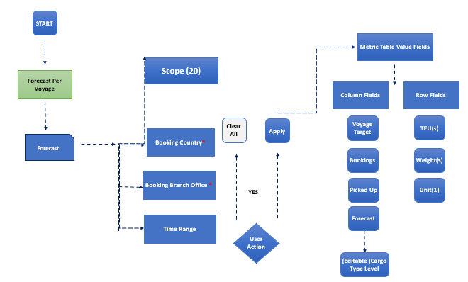

### UI / UX Design

**Mockup on Figma:** [Forecasting - DATAWAYS-COA (figma.com)](https://www.figma.com/proto/xy8DT97bl6eT0aOZUqAnsY/DATAWAYS-COA?node-id=10959-312159&t=lFwiVs7BaP8zEXVT-0&scaling=min-zoom&content-scaling=fixed&page-id=10959%3A312108)

1. Default View of the Forecast Per Voyage screen will have: *Please note navigation to the Forecast Screen are explained in Doc Ref ALL – 114 Forecast Screen Header*

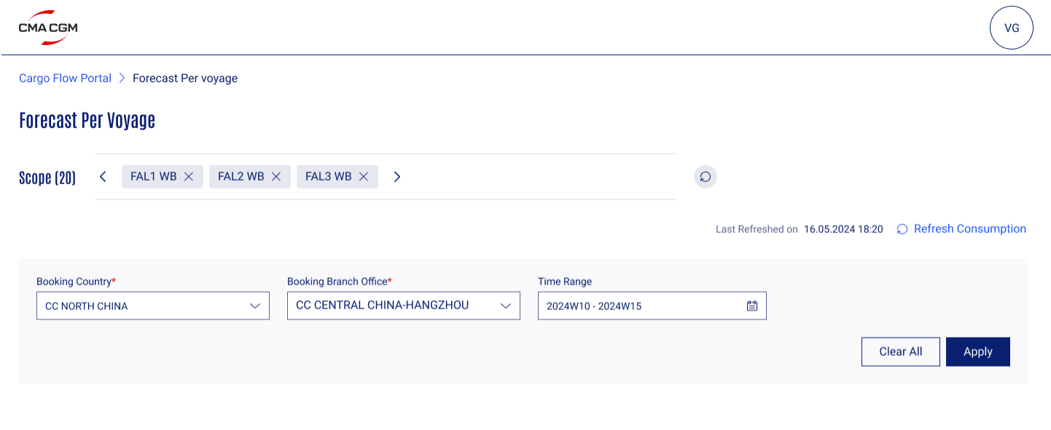

*Please note navigation to the Forecast Screen are explained in Doc Ref ALL – 114 Forecast Screen Header*

1. Once the user clicks on the ‘Apply’ button value field table for the Forecast screen will be displayed.
   1. The user will have 2 tabs ‘Long Leg’ and ‘Short Leg’
   2. By default, Long Leg tab will be on display.
   3. The user can see the matrix table for service week of CVN in specified ‘dimensions’ and ‘units’ within rows and columns.
   4. The columns will display ‘Voyage Target (Standard Alloc), Bookings, Picked-Up and Forecast’.
   5. The rows will display Unit of Measurements in Rows as, TEUs, Weights and Units.
   6. The table further expands for the user to check the how the allocation is spread across from top down.

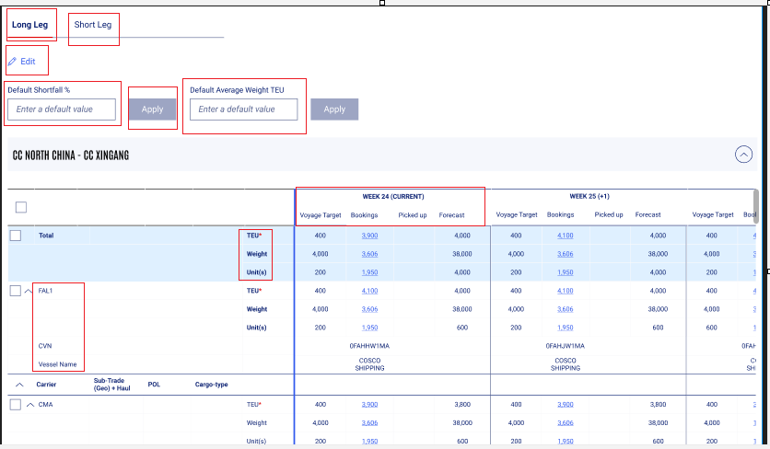

### Validation and Rules

Below are the detailed definitions for attributes, buttons, and error messages in search & display and editing boundary templates.

|  |  |  |  |  |  |  |  |
| --- | --- | --- | --- | --- | --- | --- | --- |
| **SR** | **Label or Fields** | **Description** | **F** | **A** | **D** | **List** | **Rules** |
| 1 | POL | Port of Loading to be selected by the user | FA | M | E |  |  |
| 2 | Cargo Type | Cargo Type to be selected by the user | LOV | M | E |  |  |
| 3 | Clear All | This button to be clicked by the user to discard any changes made within the table | BT |  | E |  |  |
| 4 | Apply | This button to be clicked by the user to apply to view the booking consumption the table. | BT |  | E |  |  |
| 5 | Alloc TEU | Maximum TEU to be added by the user | FN | O | E |  |  |
| 6 | Alloc TONS | Maximum weight (in tons) to be added by the user | FN | O | E D |  |  |
| 7 | Alloc Unit(s) | Maximum allowed units to be added by the user | FN | O | E |  |  |
|  |  |  |  |  |  |  |  |

**Legend**

|  |  |  |  |  |  |  |  |  |
| --- | --- | --- | --- | --- | --- | --- | --- | --- |
| Format | CB | Check Box | Attribute | M | Mandatory | Display | D | Field disabled |
| FA | Field alpha | O | Optional | E | Field Enabled |
| FN | Field numeric |  |  | R | Read Only |
| LOV | List of Value |  |  | H | Hidden |
| DA | Date |  |  |  |  |
| BT | Button |  |  |  |  |
| DT | Date Time |  |  |  |  |

### Setups and configurations

N/A

### Processing definition

Following business rules must be implemented:

|  |  |  |
| --- | --- | --- |
| **ALL- 607** | | |
| **ALL-607: COA – Forecast [Forecast Screen – TEU, Weight, Unit Columns]** | | |
| Note | *Please note navigation to the Forecast Screen are explained in Doc Ref ALL – 114 Forecast Screen Header* | |
| *~~Note~~* | *~~Please note the Bookmark Scope & Features are defined in Doc Ref ALL- 1944 separately.~~* | |
| **BR01** | **Matrix Table: A user can see matrix table** for each service / Week-CVN the below listed   1. Dimensions in Columns: Voyage Target (Standard Alloc), Bookings, Picked Up, Forecast 2. Unit of Measures in Rows: TEU, Weight, unit(s)   Additionally, the user can also check the Booking Country and Booking Brance Office name as **a table header** on top right corner of the matrix table | |
| **BR02** | **Cargo Type Level:** The user will have one more row available to the user to forecast the Short Fall % in the matrix table. |
| **BR03** | **The following logic shall apply to the column fields:**   1. Voyage Target (Standard Alloc), Bookings, Picked Up **not editable field.** 2. Forecast column values are **editable field only at Cargo Type level.** 3. Voyage Target (Standard Alloc) values **are retrieved from COA at Voyage**. 4. Bookings column values **are retrieved from COA at Voyage**. 5. *When there is no booking consumption,* ***the value 0 is displayed***.   *\*\*Picked Up: retrieved from Tracking System (LARA): Number of containers within the booked quantities, with a MOS(empty out to shipper) tracking move code.* | |
| **BR04** | **The following logic shall apply to the row fields:**   * 1. TEU, Weight, Units are displayed with the **same integer or decimals rules as defined in COA**.   2. Average Weight is **retrieved from COA** and displayed with the integer rules than defined in COA.   3. Shortfall % value field is blanked in all columns **except Forecast where the field is editable** | |
| *Note* | *The logic to sum up the values to parent level is the same as described in COA Template, i.e. values are entered by user at cargo type level only, and the data is summed up to each parent level automatically* | |
| **BR05** | **Cargo Type Reefer:** As a user while editing value for Cargo Type Reefer, it is mandatory to add a value under units. The Unit(s) are also marked in **Asterix\*** to indicate they are mandatory to be filled in the Forecast column.  *\*\*The edit function is explained in ALL-115: COA – Forecast [Edit TEU, Weight, Units]* | |



### Functional Test Cases

|  |  |  |  |  |
| --- | --- | --- | --- | --- |
| **Test Case #** | **Rule** | **Functional Test** | | **Expected Results** |
| **ALL-607: COA – Forecast [Forecast Screen – TEU, Weight, Unit Columns]** | | | | |
| **TC01** |  | | Check whether all the elements on the Operational Restrictions screen matches with the UX/UI Mock-ups | Refer section 2.6 UX/UI Designs. |
| **TC02** | BR01 | | The user on the Forecast at Voyage screen can access Forecast tab | The Forecast Tab is enabled for the user. |
| **TC03** | BR01 | | Matrix Table | The user should have the matrix table enable for them to access the value in the rows and columns for bookings. |
| **TC04** | BR03 | | Dimensions in Columns | 1) Voyage Target.  2) Bookings  3) Picked Up.  4) Forecast. |
| **TC05** | BR03 | | Dimensions in Columns | Forecast column is the only field that is **editable** for the user at Cargo Type level |
| **TC06** | BR03 | | Logic for column fields | Voyage Target, Bookings, Picked Up are not editable fields and Forecast editable field only at Cargo Type level. |
| **TC07** | BR03 | | Logic for column fields | Voyage Target, retrieved from COA at Voyage |
| **TC08** | BR03 | | Logic for column fields | Bookings retrieved from COA at Voyage |
| **TC09** | BR03 | | Logic for column fields | When there is no booking consumption, the **value 0 is displayed** |
| **TC10** | BR03 | | Logic for column fields | Picked Up: retrieved from Tracking System (LARA): Number of containers within the booked quantities, with a MOS tracking move code |
| **TC11** | BR04 | | Logic for row fields | TEU, Weight, Units are displayed with the same integer or decimals rules than defined in COA |
| **TC12** | BR04 | | Logic for row fields | Average Weight is retrieved from COA and displayed with the integer rules than defined in COA |
| **TC13** | BR04 | | Logic for row fields | Shortfall % is blanked in all columns except Forecast where the field is editable |
| **TC14** | BR05 | | Cargo Type Reefer | It is mandatory to add a value under units for the user while editing Cargo Type Reefer. |
| **TC15** | BR01 | | Metrix Table Header | The user can also check the **Booking Country and Booking Brance Office** name on top right corner of the matrix table |
|  |  | |  |  |
|  |  | |  |  |

# - Technical Details (Optional)

Technical solution will be done by architect and development teams.

- End of document –